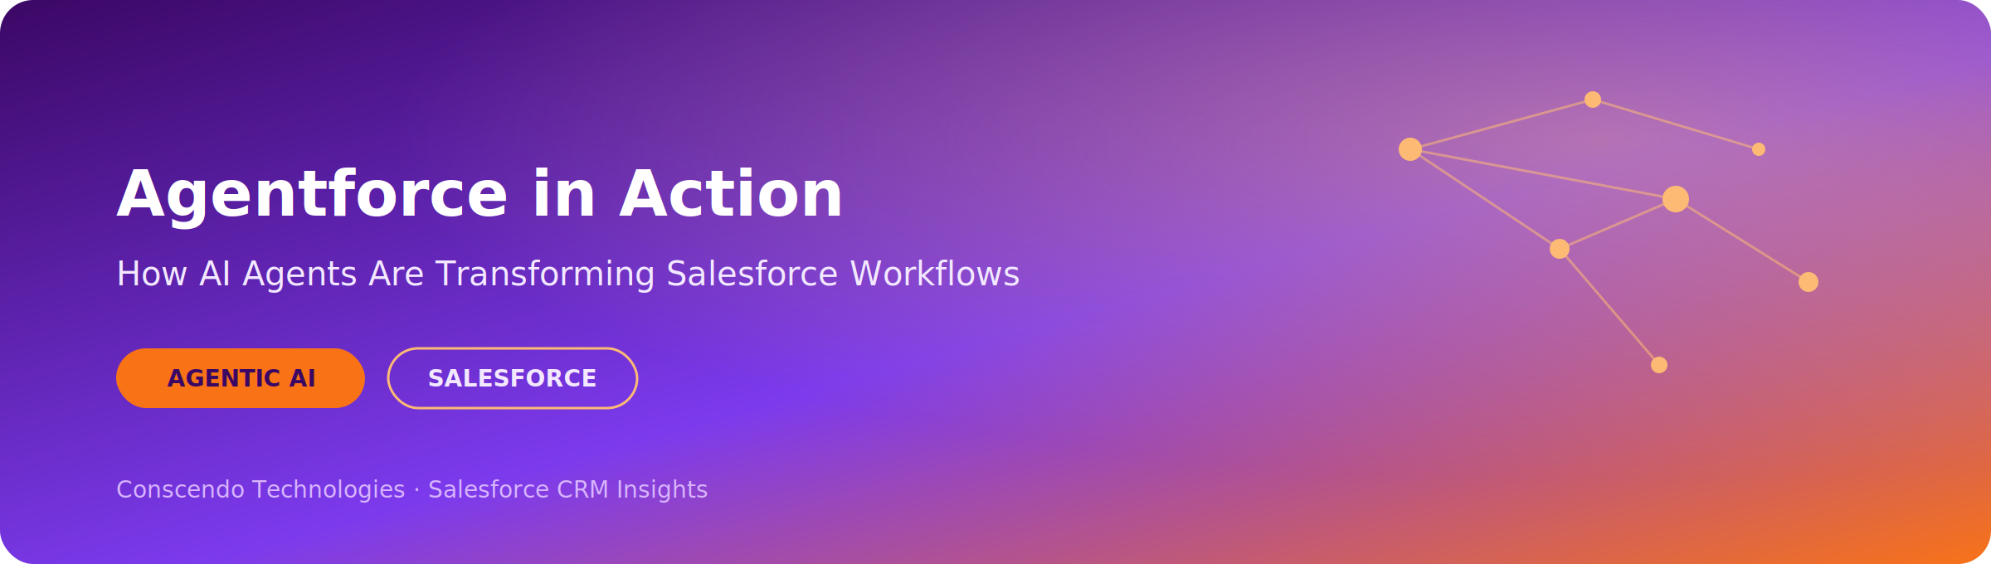
Agentforce in Action: How AI Agents Are Transforming Salesforce Workflows
July 6, 2026 · Conscendo Technologies
AI has mostly been about conversation — answering questions, drafting content. Useful, but passive. Salesforce's Agentforce changes that: AI that doesn't just advise, but acts.
It's a platform for building autonomous AI agents that understand what a business needs, reason through the steps to get there, and execute the work — inside Salesforce, within boundaries an admin has defined. Think of it as a new hire who already knows your systems and checks in with a human when a decision calls for judgment.

The Building Blocks of an AI Agent
Every agent balances two forces: human oversight and autonomous action. What bridges them is memory, reactivity, and access to tools like APIs and code execution. Agents come in a few flavors too — from simple reflex agents that react to input, up to learning agents that improve with experience. And they get deployed in three patterns: a single agent working solo, multiple agents collaborating, or a human staying in the loop. Agentforce uses all three, depending on the task.
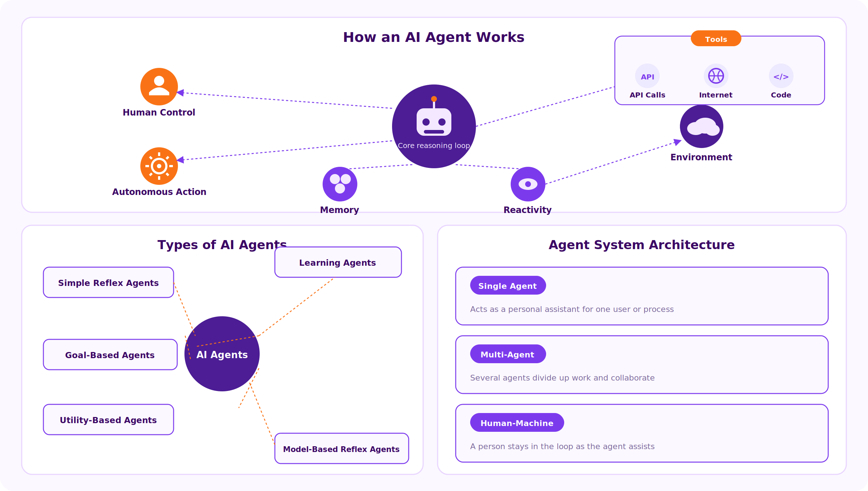
How an AI agent works, the main agent types, and the three deployment patterns.

From Rules to Reasoning
Most teams already automate with Salesforce Flow or Apex — but that's rule-following, not reasoning. It breaks the moment a request falls outside its rules. Agentforce adds a layer on top: instead of asking “which process should fire,” it asks “what is this person actually trying to accomplish?” That's the shift that lets it handle messy, non-linear requests a rigid workflow can't.
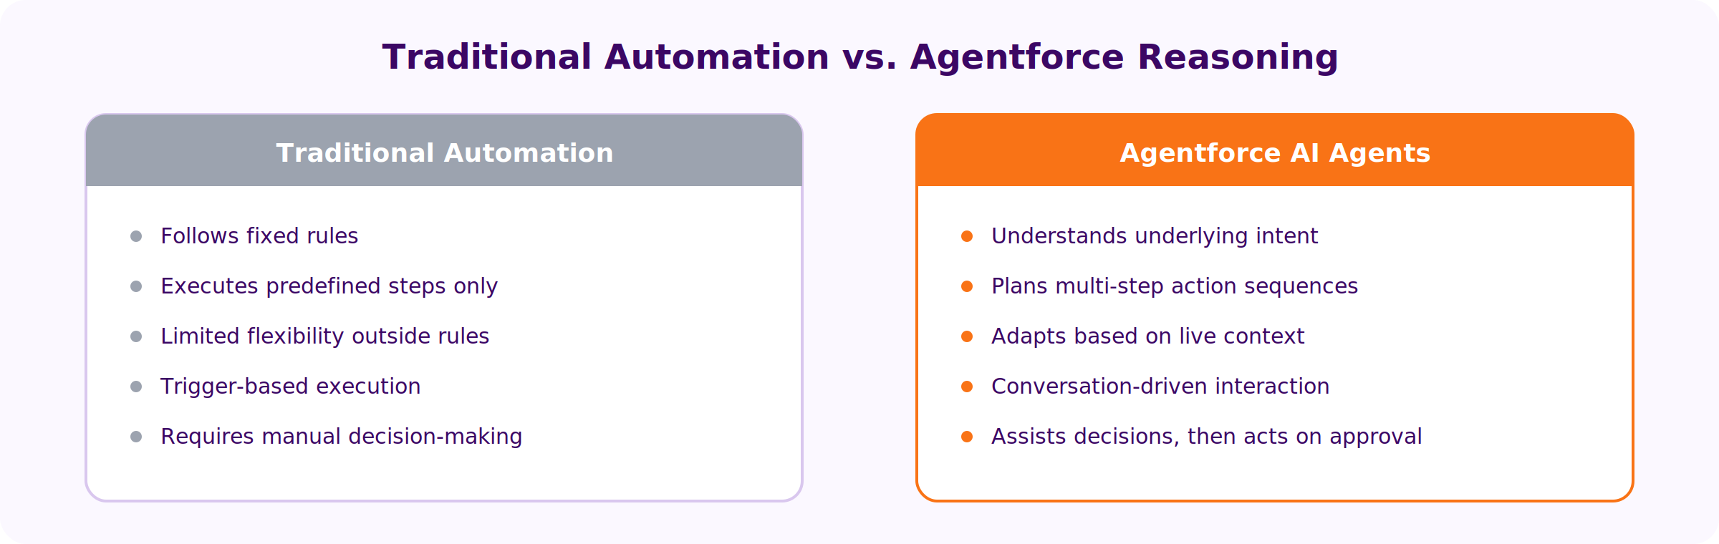
Rules follow. Agents understand.

Four Steps, Every Time
Every Agentforce request moves through the same cycle, usually in seconds:
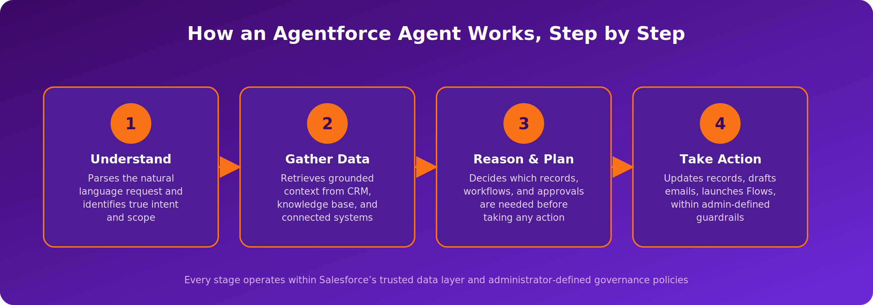
Understand, gather, plan, act — the core reasoning loop.
Understand. Parse what's actually being asked, not just the surface query.
Gather. Pull only from trusted sources — CRM records, knowledge articles, connected systems.
Plan. Decide what needs approval and whether a human should step in.
Act. Update a record, send an email, launch a Flow — inside admin-defined guardrails.

Under the Hood
Zoom in and the cycle looks like this: an LLM classifies the topic, guardrails confirm it's allowed, the prompt is assembled with context, and the model decides whether to respond or act. If it acts, that means Apex, Flow, an API call, or a RAG retrieval step — and the result feeds back into the action loop for the next step.
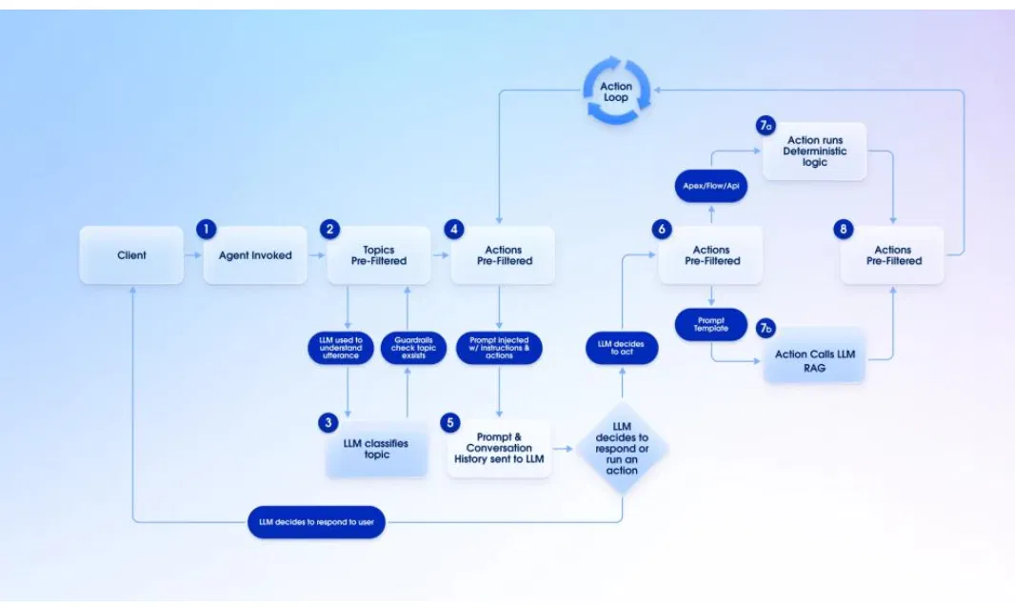
Request routing, reasoning, and the action loop that closes the cycle.

One Agent, Every Channel
Email, chat, Slack, voice — Agentforce sits behind all of them, routed through the same trust layer. A customer gets the same grounded answer whether they message or call, and the integration work only happens once.
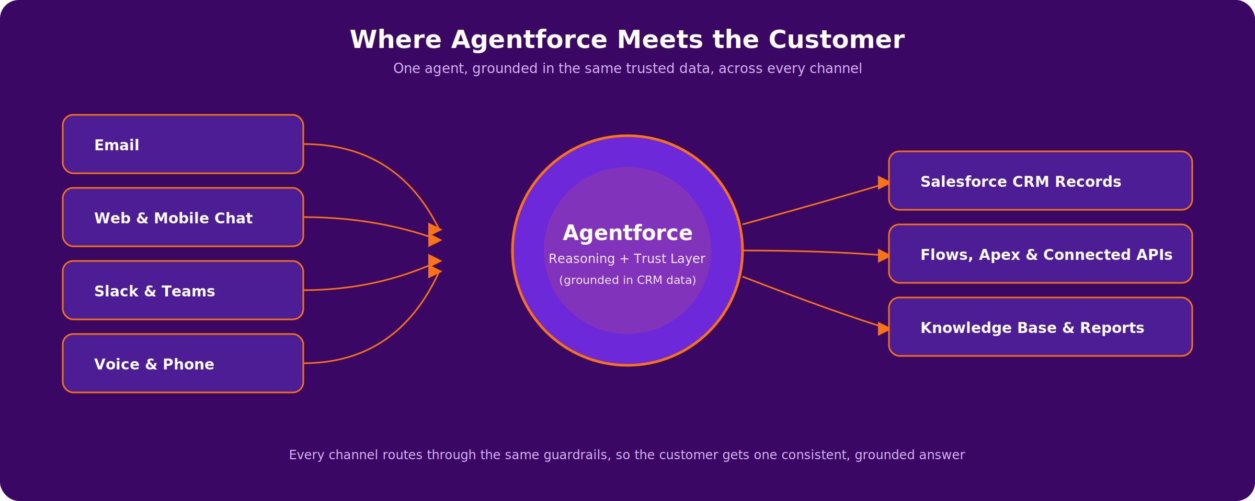
One agent, grounded in the same trusted data, across every channel.

Where It's Already Working
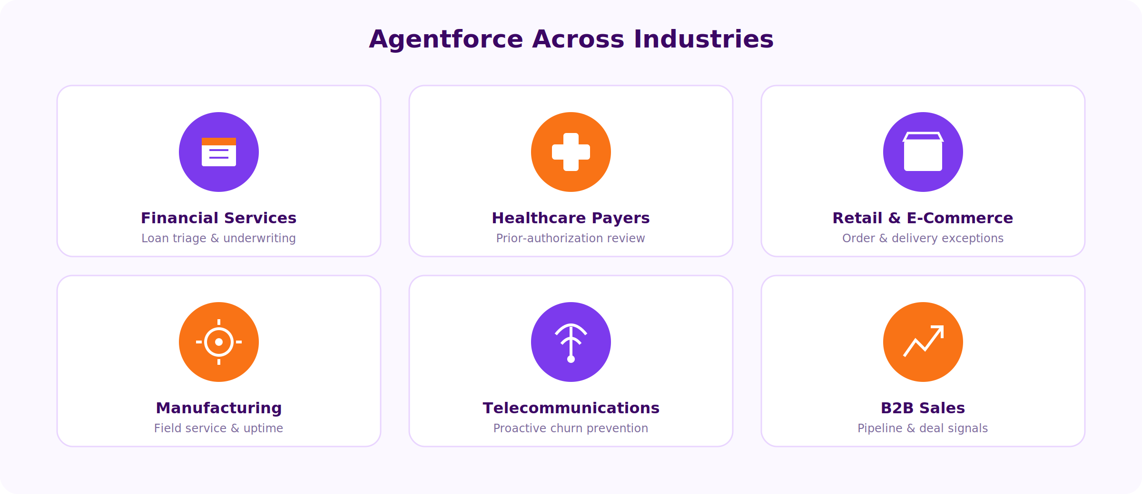
Agentforce across financial services, healthcare, retail, manufacturing, telecom, and B2B sales.
The same idea works earlier in the sales funnel too: an agent can pull deal signals straight out of email threads, meeting notes, and Slack, then auto-update the CRM itself.
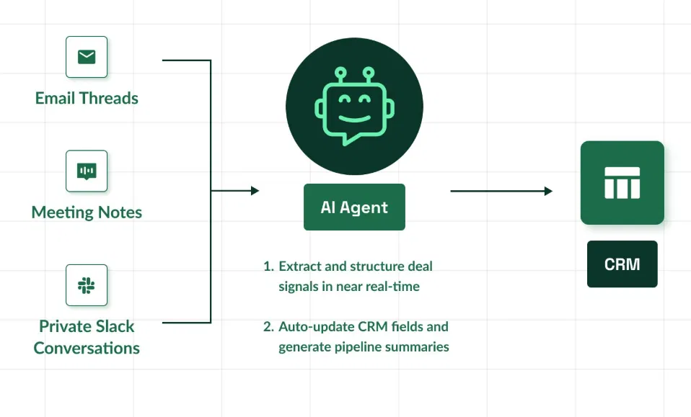
Extracting deal signals from scattered conversations, straight into the CRM.

The Trust Layer
None of this works without solid governance. Every response is grounded in the organization's own data, and every action passes through explicit checks — what the agent can see, what it's allowed to do, and where a human has to sign off.
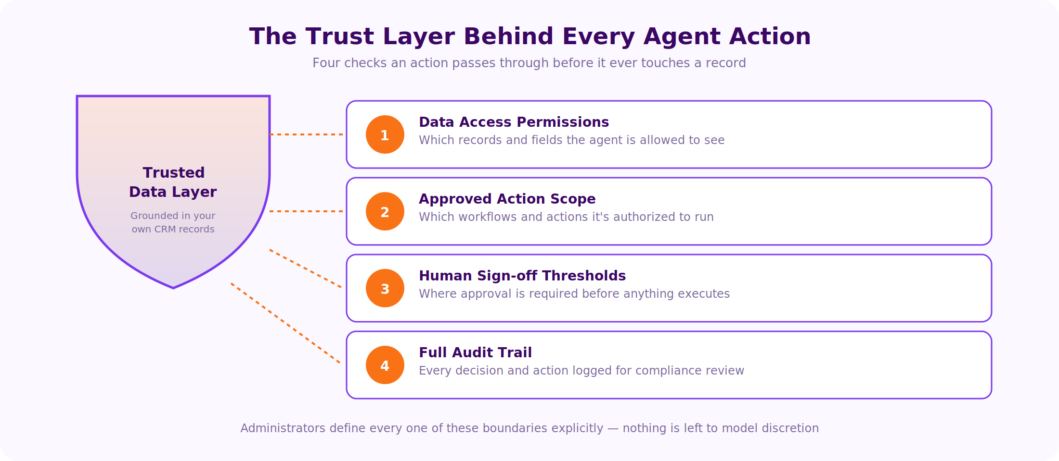
Four checkpoints every action passes through before it touches a record.

What Organizations Gain
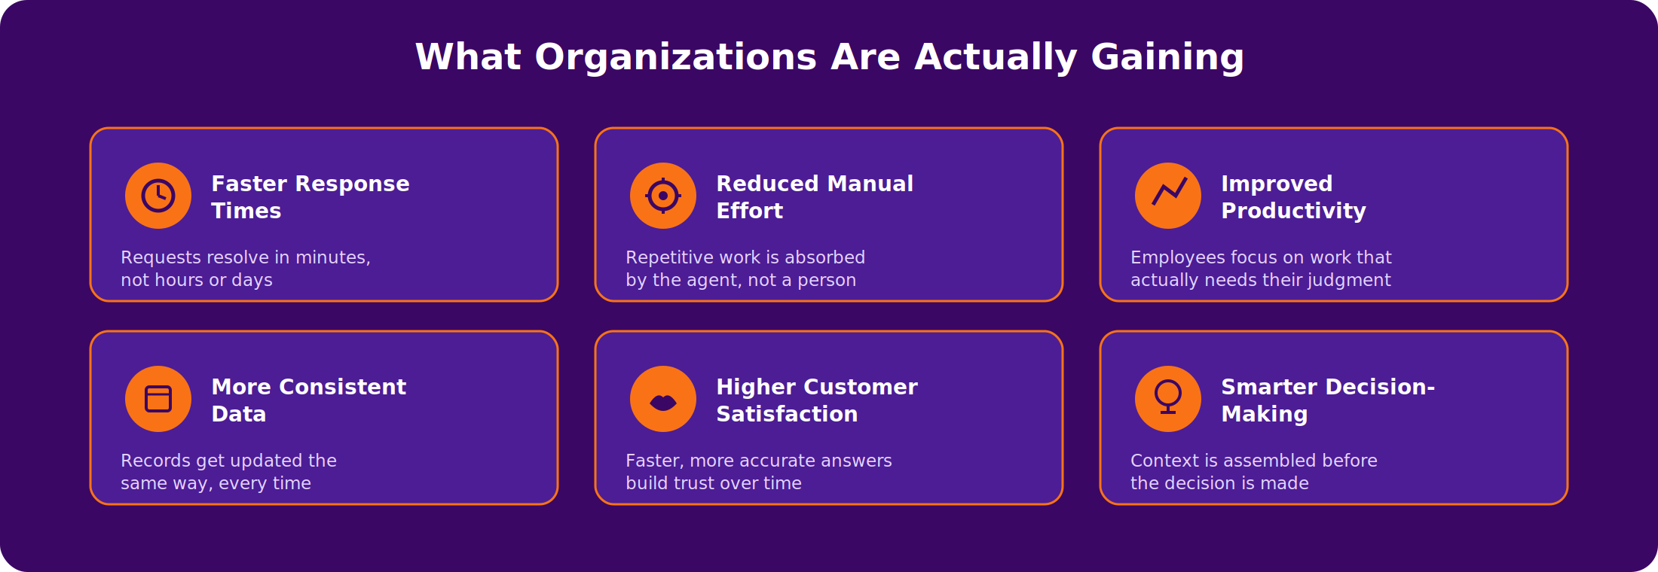
The recurring pattern across every use case.
The bigger shift is structural: scaling operations without scaling headcount at the same rate.

Start Small, on Purpose
The teams getting the most out of this pick one scoped process, clean their data first, and define guardrails explicitly before expanding.
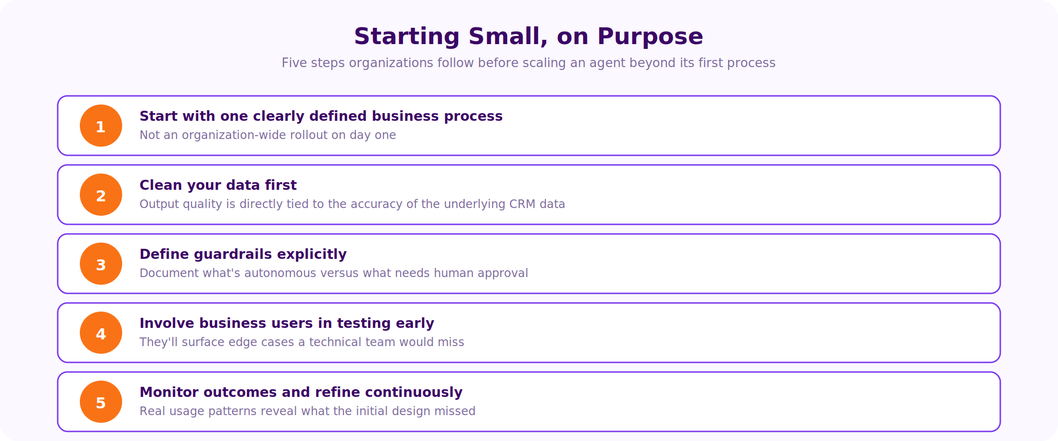
Process discipline matters as much as the technology itself.

Where This Is Headed
AI inside Salesforce is moving from assisting people to working alongside them. As agents absorb more routine decisions, what's left for employees is the work that actually needs a human — strategy, judgment, relationships. Not automation for its own sake, but a CRM that reasons alongside the people using it.

Key Takeaways
- Agentforce brings autonomous AI agents natively into Salesforce.
- Agents reason with trusted data and act within defined guardrails.
- Already at work across banking, healthcare, retail, manufacturing, telecom, and sales.
- Success depends on clean data, clear governance, and well-scoped use cases.
- The goal is AI working alongside people, not replacing them.
“The best AI doesn't replace your workforce — it amplifies it.”

Conscendo Technologies helps organizations design, govern, and scale AI-powered workflows. Get in touch to explore how Agentforce could fit your business.

